RMNP Intelimon Update
Christina Fossum
2026-03-10

Models for RMNP intelimon data

Contents:
- ROMO_East_Fuels:
  - ROMO_East_Fuels_PRE_TotalAll: model for pre-burn total fuel load (tons/acre)
  - ROMO_East_Fuels_POST_TotalAll: model for post-burn total fuel load (tons/acre)
  - ROMO_East_Fuels_YR01_TotalAll: model for yr01-post-burn total fuel load (tons/acre)
- ROMO_East_Trees
  - ROMO_East_TotalTreeCount: model for total tree count per plot
  - ROMO_East_LiveTreeCount: model for live tree count per plot
  - ROMO_East_TotalTreesPerAcre: model for total trees per acre
  - ROMO_East_meanCBH: model for mean canopy base height
- ROMO_East_RX
  - ROMO_East_RX_SubSev: model for post-burn substate burn severity
  - ROMO_East_RX_MeanScPct: model for average percent scorch
  - ROMO_East_RX_MeanScHt: model for average scorch height (m)
- ROMO_West_Fuels
  - ROMO_West_Fuels_TotalAll: model for mixed conifer total fuel load (tons/acre)
  - ROMO_West_Fuels_TotalWood: model for mixed conifer total woody fuel load (tons/acre)

1. ROMO_East_Fuels

a. ROMO_East_Fuels_PRE_TotalAll
model formula: lm1 <- lm(formula = train_pred$TotalAll ~ h_GC_kurt + MaxSD + hr100_1000_l1_median )
library(tidyverse)
## ── Attaching core tidyverse packages ──────────────────────── tidyverse 2.0.0 ──
## ✔ dplyr 1.1.4 ✔ readr 2.1.6
## ✔ forcats 1.0.1 ✔ stringr 1.6.0
## ✔ ggplot2 4.0.2 ✔ tibble 3.3.1
## ✔ lubridate 1.9.4 ✔ tidyr 1.3.2
## ✔ purrr 1.2.1
## ── Conflicts ────────────────────────────────────────── tidyverse_conflicts() ──
## ✖ dplyr::filter() masks stats::filter()
## ✖ dplyr::lag() masks stats::lag()
## ℹ Use the conflicted package (<http://conflicted.r-lib.org/>) to force all conflicts to become errors
library(leaps)
library(performance)
library(ggplot2)
# Load pred / vars data
pred <- read.csv("TLS/intelimon models/RMNP Intelimon Update/1. ROMO_East_Fuels/a. ROMO_East_Fuels_PRE_TotalAll/ROMO_East_Fuels_PRE_TotalAll_pred.csv")
vars <- read.csv("TLS/intelimon models/RMNP Intelimon Update/1. ROMO_East_Fuels/a. ROMO_East_Fuels_PRE_TotalAll/ROMO_East_Fuels_PRE_TotalAll_vars.csv")
# Create training/test data
set.seed(123)
sample_size <- floor(0.15* nrow(vars))
test_indices <- sample(seq_len(nrow(vars)), size = sample_size)
train_vars <- vars[-test_indices, ]
test_vars <- vars[test_indices, ]
train_pred <- pred[-test_indices, ]
test_pred <- pred[test_indices, ]
# Load model
lm1<- readRDS("TLS/intelimon models/RMNP Intelimon Update/1. ROMO_East_Fuels/a. ROMO_East_Fuels_PRE_TotalAll/ROMO_East_Fuels_PRE_TotalAll.rda")
#look at the summary r2 values and RMSE & check model for colinearity
summary(lm1)
##
## Call:
## lm(formula = train_pred$TotalAll ~ h_GC_kurt + MaxSD + hr100_1000_l1_median)
##
## Residuals:
## Min 1Q Median 3Q Max
## -10.7342 -3.5092 -0.3031 2.8960 16.3217
##
## Coefficients:
## Estimate Std. Error t value Pr(>|t|)
## (Intercept) -3.7853 3.3227 -1.139 0.2604
## h_GC_kurt 6.3071 3.4247 1.842 0.0718 .
## MaxSD 0.4959 0.1046 4.740 2.01e-05 ***
## hr100_1000_l1_median 168.3444 19.2274 8.755 1.95e-11 ***
## ---
## Signif. codes: 0 '***' 0.001 '**' 0.01 '*' 0.05 '.' 0.1 ' ' 1
##
## Residual standard error: 5.311 on 47 degrees of freedom
## Multiple R-squared: 0.6858, Adjusted R-squared: 0.6657
## F-statistic: 34.19 on 3 and 47 DF, p-value: 7.11e-12
r2(lm1)
## # R2 for Linear Regression
## R2: 0.686
## adj. R2: 0.666
rmse(lm1)
## [1] 5.098201
check_model(lm1)
# Plot observed values vs. predicted
lm_out <- predict.lm(lm1, vars)
data<-data.frame(x=lm_out, y=pred$TotalAll)
ggplot(data,aes(x,y)) +
geom_point() +
geom_smooth(method='lm', se=FALSE,) +
theme_light() +
labs(x='Predicted Values', y='Observed Values', title='Pre-Burn Total Fuels') +
theme(plot.title = element_text(hjust=0.5, size=20, face='bold')
)
## `geom_smooth()` using formula = 'y ~ x'
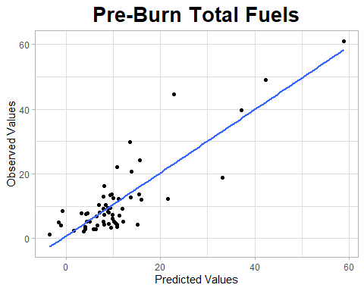
# use the model to predict test data
test_out<- predict.lm(lm1,test_vars)
errors<- test_out - test_pred$TotalAll
mae <- mean(abs(errors))
mse <- mean(errors^2)
rmse <- sqrt(mse)
rmse
## [1] 10.41917
# Plot test observed values vs. test predicted
data2<- data.frame(x=test_out, y=test_pred$TotalAll)
ggplot(data2,aes(x,y)) +
geom_point() +
geom_smooth(method='lm', se=FALSE,) +
theme_light() +
labs(x='Predicted Values', y='Observed Values', title='test') +
theme(plot.title = element_text(hjust=0.5, size=20, face='bold')
)
## `geom_smooth()` using formula = 'y ~ x'
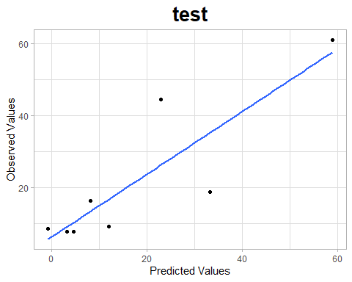

b. ROMO_East_Fuels_POST_TotalAll
model formula: lm1 <- lm(formula = train_pred$TotalAll ~ h_l1_kurt + h_l3_cnt + LF_SLPD )
library(tidyverse)
library(leaps)
library(performance)
library(ggplot2)
# Load pred / vars data
pred <- read.csv("TLS/intelimon models/RMNP Intelimon Update/1. ROMO_East_Fuels/b. ROMO_East_Fuels_POST_TotalAll/ROMO_East_Fuels_POST_TotalAll_pred.csv")
vars <- read.csv("TLS/intelimon models/RMNP Intelimon Update/1. ROMO_East_Fuels/b. ROMO_East_Fuels_POST_TotalAll/ROMO_East_Fuels_POST_TotalAll_vars.csv")
# Create training/test data
set.seed(123)
sample_size <- floor(0.2* nrow(vars))
test_indices <- sample(seq_len(nrow(vars)), size = sample_size)
train_vars <- vars[-test_indices, ]
test_vars <- vars[test_indices, ]
train_pred <- pred[-test_indices, ]
test_pred <- pred[test_indices, ]
# Load model
lm1<- readRDS("TLS/intelimon models/RMNP Intelimon Update/1. ROMO_East_Fuels/b. ROMO_East_Fuels_POST_TotalAll/ROMO_East_Fuels_POST_TotalAll.rda")
#look at the summary r2 values and RMSE & check model for colinearity
summary(lm1)
##
## Call:
## lm(formula = train_pred$TotalAll ~ h_l1_kurt + h_l3_cnt + LF_SLPD)
##
## Residuals:
## Min 1Q Median 3Q Max
## -0.90999 -0.44023 0.08501 0.22423 1.03484
##
## Coefficients:
## Estimate Std. Error t value Pr(>|t|)
## (Intercept) 1.465e+00 8.945e-01 1.637 0.13259
## h_l1_kurt -3.174e+00 8.365e-01 -3.795 0.00352 **
## h_l3_cnt 7.863e-06 2.205e-05 0.357 0.72883
## LF_SLPD -1.560e-01 6.291e-02 -2.480 0.03257 *
## ---
## Signif. codes: 0 '***' 0.001 '**' 0.01 '*' 0.05 '.' 0.1 ' ' 1
##
## Residual standard error: 0.6684 on 10 degrees of freedom
## Multiple R-squared: 0.6479, Adjusted R-squared: 0.5423
## F-statistic: 6.135 on 3 and 10 DF, p-value: 0.0123
r2(lm1)
## # R2 for Linear Regression
## R2: 0.648
## adj. R2: 0.542
rmse(lm1)
## [1] 0.5648781
check_model(lm1)
# Plot observed values vs. predicted
lm_out <- predict.lm(lm1, vars)
data<-data.frame(x=lm_out, y=pred$TotalAll)
ggplot(data,aes(x,y)) +
geom_point() +
geom_smooth(method='lm', se=FALSE,) +
theme_light() +
labs(x='Predicted Values', y='Observed Values', title='Post-Burn Total Fuels') +
theme(plot.title = element_text(hjust=0.5, size=20, face='bold')
)
## `geom_smooth()` using formula = 'y ~ x'
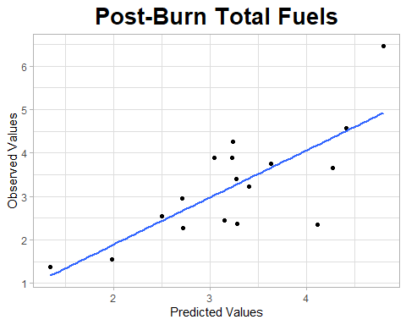
# use the model to predict test data
test_out<- predict.lm(lm1,test_vars)
errors<- test_out - test_pred$TotalAll
mae <- mean(abs(errors))
mse <- mean(errors^2)
rmse <- sqrt(mse)
rmse
## [1] 1.405266
# Plot test observed values vs. test predicted
data2<- data.frame(x=test_out, y=test_pred$TotalAll)
ggplot(data2,aes(x,y)) +
geom_point() +
geom_smooth(method='lm', se=FALSE,) +
theme_light() +
labs(x='Predicted Values', y='Observed Values', title='test') +
theme(plot.title = element_text(hjust=0.5, size=20, face='bold')
)
## `geom_smooth()` using formula = 'y ~ x'
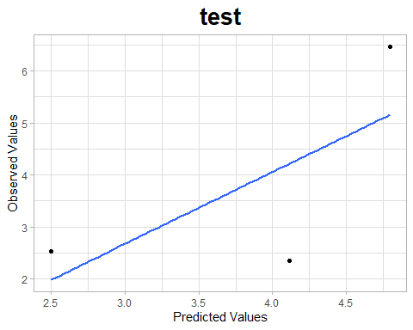

c. ROMO_East_Fuels_YR01_TotalAll
model formula: lm1 <- lm(formula = train_pred$TotalAll ~ h_ground_cnt + shrubs_l1_median )
library(tidyverse)
library(leaps)
library(performance)
library(ggplot2)
# Load pred / vars data
pred <- read.csv("TLS/intelimon models/RMNP Intelimon Update/1. ROMO_East_Fuels/c. ROMO_East_Fuels_YR01_TotalAll/ROMO_East_Fuels_YR01_TotalAll_pred.csv")
vars <- read.csv("TLS/intelimon models/RMNP Intelimon Update/1. ROMO_East_Fuels/c. ROMO_East_Fuels_YR01_TotalAll/ROMO_East_Fuels_YR01_TotalAll_vars.csv")
# Create training/test data
set.seed(123)
sample_size <- floor(0.25* nrow(vars))
test_indices <- sample(seq_len(nrow(vars)), size = sample_size)
train_vars <- vars[-test_indices, ]
test_vars <- vars[test_indices, ]
train_pred <- pred[-test_indices, ]
test_pred <- pred[test_indices, ]
# Load model
lm1<- readRDS("TLS/intelimon models/RMNP Intelimon Update/1. ROMO_East_Fuels/c. ROMO_East_Fuels_YR01_TotalAll/ROMO_East_Fuels_YR01_TotalAll.rda")
#look at the summary r2 values and RMSE & check model for colinearity
summary(lm1)
##
## Call:
## lm(formula = train_pred$TotalAll ~ h_ground_cnt + shrubs_l1_median)
##
## Residuals:
## Min 1Q Median 3Q Max
## -0.61665 -0.21966 0.08063 0.20043 0.40302
##
## Coefficients:
## Estimate Std. Error t value Pr(>|t|)
## (Intercept) -1.650e+01 2.270e+00 -7.269 0.000167 ***
## h_ground_cnt 1.656e-05 1.801e-06 9.195 3.71e-05 ***
## shrubs_l1_median -1.315e+00 2.151e-01 -6.112 0.000485 ***
## ---
## Signif. codes: 0 '***' 0.001 '**' 0.01 '*' 0.05 '.' 0.1 ' ' 1
##
## Residual standard error: 0.3906 on 7 degrees of freedom
## Multiple R-squared: 0.9265, Adjusted R-squared: 0.9055
## F-statistic: 44.11 on 2 and 7 DF, p-value: 0.0001077
r2(lm1)
## # R2 for Linear Regression
## R2: 0.926
## adj. R2: 0.905
rmse(lm1)
## [1] 0.3267994
check_model(lm1)
# Plot observed values vs. predicted
lm_out <- predict.lm(lm1, vars)
data<-data.frame(x=lm_out, y=pred$TotalAll)
ggplot(data,aes(x,y)) +
geom_point() +
geom_smooth(method='lm', se=FALSE,) +
theme_light() +
labs(x='Predicted Values', y='Observed Values', title='Yr01 Post-Burn Total Fuels') +
theme(plot.title = element_text(hjust=0.5, size=20, face='bold')
)
## `geom_smooth()` using formula = 'y ~ x'
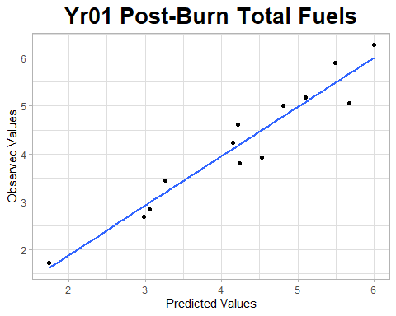
# use the model to predict test data
test_out<- predict.lm(lm1,test_vars)
errors<- test_out - test_pred$TotalAll
mae <- mean(abs(errors))
mse <- mean(errors^2)
rmse <- sqrt(mse)
rmse
## [1] 0.4097384
# Plot test observed values vs. test predicted
data2<- data.frame(x=test_out, y=test_pred$TotalAll)
ggplot(data2,aes(x,y)) +
geom_point() +
geom_smooth(method='lm', se=FALSE,) +
theme_light() +
labs(x='Predicted Values', y='Observed Values', title='test') +
theme(plot.title = element_text(hjust=0.5, size=20, face='bold')
)
## `geom_smooth()` using formula = 'y ~ x'
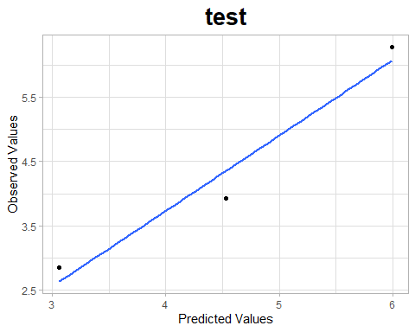

2. ROMO_East_Trees

a. ROMO_East_TotalTreeCount
model formula: lm1 <- lm(formula = train_pred$TreeCount ~ h_MS_cnt + h_MS_per + fuel0_3l1_kurt)
library(tidyverse)
library(leaps)
library(performance)
library(ggplot2)
# Load pred / vars data
pred <- read.csv("TLS/intelimon models/RMNP Intelimon Update/2. ROMO_East_Trees/a. ROMO_East_TotalTreeCount/ROMO_EAST_TotalTreeCount_pred.csv")
vars <- read.csv("TLS/intelimon models/RMNP Intelimon Update/2. ROMO_East_Trees/a. ROMO_East_TotalTreeCount/ROMO_EAST_TotalTreeCount_vars.csv")
# Create training/test data
set.seed(123)
sample_size <- floor(0.2* nrow(vars))
test_indices <- sample(seq_len(nrow(vars)), size = sample_size)
train_vars <- vars[-test_indices, ]
test_vars <- vars[test_indices, ]
train_pred <- pred[-test_indices, ]
test_pred <- pred[test_indices, ]
# Load Model
lm1 <- readRDS("TLS/intelimon models/RMNP Intelimon Update/2. ROMO_East_Trees/a. ROMO_East_TotalTreeCount/ROMO_EAST_TotalTreeCount.rda")
#look at the summary r2 values and RMSE & check model for colinearity
summary(lm1)
##
## Call:
## lm(formula = train_pred$TreeCount ~ h_MS_cnt + h_MS_per + fuel0_3l1_kurt)
##
## Residuals:
## Min 1Q Median 3Q Max
## -0.95871 -0.52565 -0.09495 0.42514 1.80458
##
## Coefficients:
## Estimate Std. Error t value Pr(>|t|)
## (Intercept) -5.667e-01 4.464e-01 -1.269 0.217571
## h_MS_cnt 6.184e-06 3.895e-07 15.877 1.56e-13 ***
## h_MS_per -3.501e-02 8.204e-03 -4.267 0.000314 ***
## fuel0_3l1_kurt 7.958e-02 1.338e-02 5.946 5.53e-06 ***
## ---
## Signif. codes: 0 '***' 0.001 '**' 0.01 '*' 0.05 '.' 0.1 ' ' 1
##
## Residual standard error: 0.7527 on 22 degrees of freedom
## Multiple R-squared: 0.9325, Adjusted R-squared: 0.9233
## F-statistic: 101.3 on 3 and 22 DF, p-value: 4.965e-13
r2(lm1)
## # R2 for Linear Regression
## R2: 0.933
## adj. R2: 0.923
rmse(lm1)
## [1] 0.6923741
check_model(lm1)
# Plot observed values vs. predicted
lm_out <- predict.lm(lm1, vars)
data<-data.frame(x=lm_out, y=pred$TreeCount)
ggplot(data,aes(x,y)) +
geom_point() +
geom_smooth(method='lm', se=FALSE,) +
theme_light() +
labs(x='Predicted Values', y='Observed Values', title='Total Tree Count') +
theme(plot.title = element_text(hjust=0.5, size=20, face='bold')
)
## `geom_smooth()` using formula = 'y ~ x'
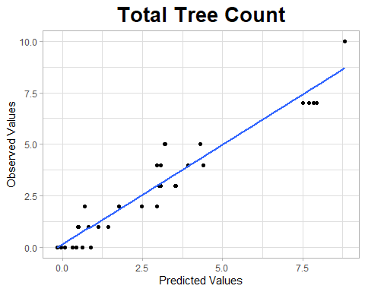
# use the model to predict test data
test_out<- predict.lm(lm1,test_vars)
errors<- test_out - test_pred$TreeCount
mae <- mean(abs(errors))
mse <- mean(errors^2)
rmse <- sqrt(mse)
rmse
## [1] 0.9988529
# Plot test observed values vs. test predicted
data2<- data.frame(x=test_out, y=test_pred$TreeCount)
ggplot(data2,aes(x,y)) +
geom_point() +
geom_smooth(method='lm', se=FALSE,) +
theme_light() +
labs(x='Predicted Values', y='Observed Values', title='test') +
theme(plot.title = element_text(hjust=0.5, size=20, face='bold')
)
## `geom_smooth()` using formula = 'y ~ x'
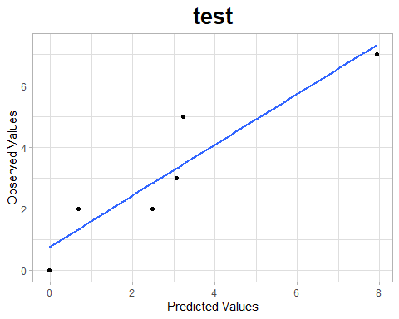

b. ROMO_East_LiveTreeCount
model formula: lm1 <- lm(formula = train_pred$L ~ h_l2_per + h_l5_cnt + fine_l1_vari)
library(tidyverse)
library(leaps)
library(performance)
library(ggplot2)
# Load pred / vars data
pred <- read.csv("TLS/intelimon models/RMNP Intelimon Update/2. ROMO_East_Trees/b. ROMO_East_LiveTreeCount/ROMO_EAST_LiveTreeCount_pred.csv")
vars <- read.csv("TLS/intelimon models/RMNP Intelimon Update/2. ROMO_East_Trees/b. ROMO_East_LiveTreeCount/ROMO_EAST_LiveTreeCount_vars.csv")
# Create training/test data
set.seed(123)
sample_size <- floor(0.2* nrow(vars))
test_indices <- sample(seq_len(nrow(vars)), size = sample_size)
train_vars <- vars[-test_indices, ]
test_vars <- vars[test_indices, ]
train_pred <- pred[-test_indices, ]
test_pred <- pred[test_indices, ]
# Load Model
lm1 <- readRDS("TLS/intelimon models/RMNP Intelimon Update/2. ROMO_East_Trees/b. ROMO_East_LiveTreeCount/ROMO_EAST_LiveTreeCount.rda")
#look at the summary r2 values and RMSE & check model for colinearity
summary(lm1)
##
## Call:
## lm(formula = train_pred$L ~ h_l2_per + h_l5_cnt + fine_l1_vari)
##
## Residuals:
## Min 1Q Median 3Q Max
## -0.82026 -0.29489 -0.06487 0.22010 0.99812
##
## Coefficients:
## Estimate Std. Error t value Pr(>|t|)
## (Intercept) -9.489e-01 2.281e-01 -4.161 0.000408 ***
## h_l2_per 2.879e-02 9.623e-03 2.992 0.006725 **
## h_l5_cnt 3.281e-06 1.665e-07 19.706 1.82e-15 ***
## fine_l1_vari -3.065e-04 6.921e-05 -4.429 0.000211 ***
## ---
## Signif. codes: 0 '***' 0.001 '**' 0.01 '*' 0.05 '.' 0.1 ' ' 1
##
## Residual standard error: 0.5178 on 22 degrees of freedom
## Multiple R-squared: 0.9574, Adjusted R-squared: 0.9516
## F-statistic: 164.8 on 3 and 22 DF, p-value: 3.176e-15
r2(lm1)
## # R2 for Linear Regression
## R2: 0.957
## adj. R2: 0.952
rmse(lm1)
## [1] 0.4763403
check_model(lm1)
# Plot observed values vs. predicted
lm_out <- predict.lm(lm1, vars)
data<-data.frame(x=lm_out, y=pred$L)
ggplot(data,aes(x,y)) +
geom_point() +
geom_smooth(method='lm', se=FALSE,) +
theme_light() +
labs(x='Predicted Values', y='Observed Values', title='Live Tree Count') +
theme(plot.title = element_text(hjust=0.5, size=20, face='bold')
)
## `geom_smooth()` using formula = 'y ~ x'
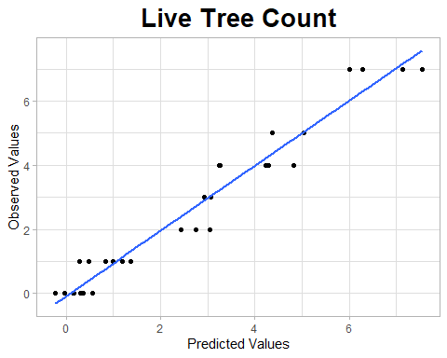
# use the model to predict test data
test_out<- predict.lm(lm1,test_vars)
errors<- test_out - test_pred$L
mae <- mean(abs(errors))
mse <- mean(errors^2)
rmse <- sqrt(mse)
rmse
## [1] 0.5586347
# Plot test observed values vs. test predicted
data2<- data.frame(x=test_out, y=test_pred$L)
ggplot(data2,aes(x,y)) +
geom_point() +
geom_smooth(method='lm', se=FALSE,) +
theme_light() +
labs(x='Predicted Values', y='Observed Values', title='test') +
theme(plot.title = element_text(hjust=0.5, size=20, face='bold')
)
## `geom_smooth()` using formula = 'y ~ x'
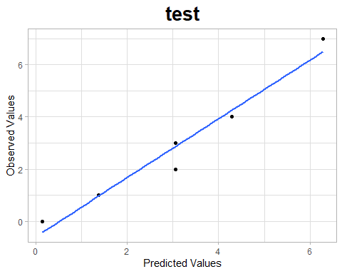

c. ROMO_East_TotalTreesPerAcre
model formula: lm1 <- lm(formula = train_pred$TotalTreesPerAcre ~ StemsPacre + shrubs_l1_cnt)
library(tidyverse)
library(leaps)
library(performance)
library(ggplot2)
# Load pred / vars data
pred <- read.csv("TLS/intelimon models/RMNP Intelimon Update/2. ROMO_East_Trees/c. ROMO_East_TotalTreesPerAcre/ROMO_EAST_TotalTreesPerAcre_pred.csv")
vars <- read.csv("TLS/intelimon models/RMNP Intelimon Update/2. ROMO_East_Trees/c. ROMO_East_TotalTreesPerAcre/ROMO_EAST_TotalTreesPerAcre_vars.csv")
# Create training/test data
set.seed(123)
sample_size <- floor(0.1* nrow(vars))
test_indices <- sample(seq_len(nrow(vars)), size = sample_size)
train_vars <- vars[-test_indices, ]
test_vars <- vars[test_indices, ]
train_pred <- pred[-test_indices, ]
test_pred <- pred[test_indices, ]
# Load Model
lm1 <- readRDS("TLS/intelimon models/RMNP Intelimon Update/2. ROMO_East_Trees/c. ROMO_East_TotalTreesPerAcre/ROMO_EAST_TotalTreesPerAcre.rda")
#look at the summary r2 values and RMSE & check model for colinearity
summary(lm1)
##
## Call:
## lm(formula = train_pred$TotalTreesPerAcre ~ StemsPacre + shrubs_l1_cnt)
##
## Residuals:
## Min 1Q Median 3Q Max
## -23.235 -10.501 -0.317 8.035 46.100
##
## Coefficients:
## Estimate Std. Error t value Pr(>|t|)
## (Intercept) -7.112e+00 3.726e+00 -1.909 0.0617 .
## StemsPacre 8.939e-01 8.531e-02 10.478 1.60e-14 ***
## shrubs_l1_cnt 1.403e-04 2.383e-05 5.886 2.75e-07 ***
## ---
## Signif. codes: 0 '***' 0.001 '**' 0.01 '*' 0.05 '.' 0.1 ' ' 1
##
## Residual standard error: 15.6 on 53 degrees of freedom
## Multiple R-squared: 0.8273, Adjusted R-squared: 0.8208
## F-statistic: 126.9 on 2 and 53 DF, p-value: < 2.2e-16
r2(lm1)
## # R2 for Linear Regression
## R2: 0.827
## adj. R2: 0.821
rmse(lm1)
## [1] 15.17942
check_model(lm1)
# Plot observed values vs. predicted
lm_out <- predict.lm(lm1, vars)
data<-data.frame(x=lm_out, y=pred$TotalTreesPerAcre)
ggplot(data,aes(x,y)) +
geom_point() +
geom_smooth(method='lm', se=FALSE,) +
theme_light() +
labs(x='Predicted Values', y='Observed Values', title='Trees Per Acre') +
theme(plot.title = element_text(hjust=0.5, size=20, face='bold')
)
## `geom_smooth()` using formula = 'y ~ x'
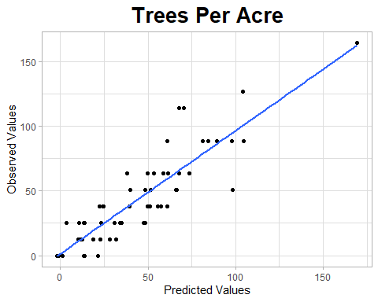
# use the model to predict test data
test_out<- predict.lm(lm1,test_vars)
errors<- test_out - test_pred$TotalTreesPerAcre
mae <- mean(abs(errors))
mse <- mean(errors^2)
rmse <- sqrt(mse)
rmse
## [1] 21.37771
# Plot test observed values vs. test predicted
data2<- data.frame(x=test_out, y=test_pred$TotalTreesPerAcre)
ggplot(data2,aes(x,y)) +
geom_point() +
geom_smooth(method='lm', se=FALSE,) +
theme_light() +
labs(x='Predicted Values', y='Observed Values', title='test') +
theme(plot.title = element_text(hjust=0.5, size=20, face='bold')
)
## `geom_smooth()` using formula = 'y ~ x'
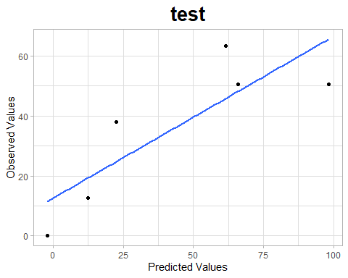

d. ROMO_East_meanCBH
model formula: lm1 <- lm(formula = train_pred$meanCBH ~ LAHV + MeanSA+ hr0_10_l1_mean)
library(tidyverse)
library(leaps)
library(performance)
library(ggplot2)
# Load pred / vars data
pred <- read.csv("TLS/intelimon models/RMNP Intelimon Update/2. ROMO_East_Trees/d. ROMO_East_meanCBH/ROMO_EAST_meanCBH_pred.csv")
vars <- read.csv("TLS/intelimon models/RMNP Intelimon Update/2. ROMO_East_Trees/d. ROMO_East_meanCBH/ROMO_EAST_meanCBH_vars.csv")
# Create training/test data
set.seed(123)
sample_size <- floor(0.1* nrow(vars))
test_indices <- sample(seq_len(nrow(vars)), size = sample_size)
train_vars <- vars[-test_indices, ]
test_vars <- vars[test_indices, ]
train_pred <- pred[-test_indices, ]
test_pred <- pred[test_indices, ]
# Load Model
lm1 <- readRDS("TLS/intelimon models/RMNP Intelimon Update/2. ROMO_East_Trees/d. ROMO_East_meanCBH/ROMO_EAST_meanCBH.rda")
#look at the summary r2 values and RMSE & check model for colinearity
summary(lm1)
##
## Call:
## lm(formula = train_pred$meanCBH ~ LAHV + MeanSA + hr0_10_l1_mean)
##
## Residuals:
## Min 1Q Median 3Q Max
## -2.11157 -0.48035 -0.09187 0.63881 2.25147
##
## Coefficients:
## Estimate Std. Error t value Pr(>|t|)
## (Intercept) -0.2972 0.4225 -0.703 0.486
## LAHV 15.9772 1.9652 8.130 3.11e-10 ***
## MeanSA -0.6221 0.1168 -5.328 3.43e-06 ***
## hr0_10_l1_mean 3.9483 0.7997 4.937 1.24e-05 ***
## ---
## Signif. codes: 0 '***' 0.001 '**' 0.01 '*' 0.05 '.' 0.1 ' ' 1
##
## Residual standard error: 1.015 on 43 degrees of freedom
## Multiple R-squared: 0.6604, Adjusted R-squared: 0.6367
## F-statistic: 27.87 on 3 and 43 DF, p-value: 3.606e-10
r2(lm1)
## # R2 for Linear Regression
## R2: 0.660
## adj. R2: 0.637
rmse(lm1)
## [1] 0.9706284
check_model(lm1)
# Plot observed values vs. predicted
lm_out <- predict.lm(lm1, vars)
data<-data.frame(x=lm_out, y=pred$meanCBH)
ggplot(data,aes(x,y)) +
geom_point() +
geom_smooth(method='lm', se=FALSE,) +
theme_light() +
labs(x='Predicted Values', y='Observed Values', title='Canopy Base Height') +
theme(plot.title = element_text(hjust=0.5, size=20, face='bold')
)
## `geom_smooth()` using formula = 'y ~ x'
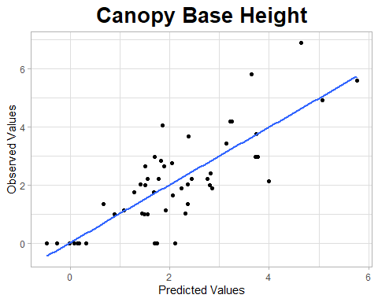
# use the model to predict test data
test_out<- predict.lm(lm1,test_vars)
errors<- test_out - test_pred$meanCBH
mae <- mean(abs(errors))
mse <- mean(errors^2)
rmse <- sqrt(mse)
rmse
## [1] 0.7608601
# Plot test observed values vs. test predicted
data2<- data.frame(x=test_out, y=test_pred$meanCBH)
ggplot(data2,aes(x,y)) +
geom_point() +
geom_smooth(method='lm', se=FALSE,) +
theme_light() +
labs(x='Predicted Values', y='Observed Values', title='test') +
theme(plot.title = element_text(hjust=0.5, size=20, face='bold')
)
## `geom_smooth()` using formula = 'y ~ x'
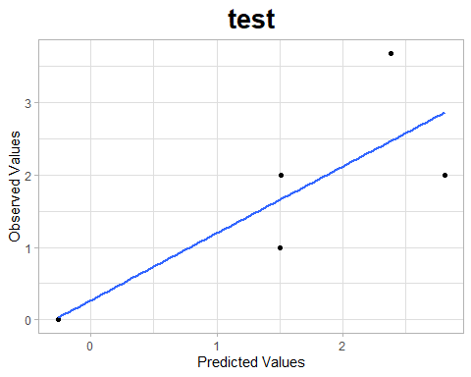

3. ROMO_East_RX

a. ROMO_East_RX_SubSev
model formula: lm1 <- lm(formula = train_pred$SubSev ~h_l4_skew +s_l4_prop_ku)
library(tidyverse)
library(leaps)
library(performance)
library(ggplot2)
# Load pred / vars data
pred <- read.csv("TLS/intelimon models/RMNP Intelimon Update/3. ROMO_East_RX/a. ROMO_East_RX_SubSev/ROMO_East_RX_SubSev_pred.csv")
vars <- read.csv("TLS/intelimon models/RMNP Intelimon Update/3. ROMO_East_RX/a. ROMO_East_RX_SubSev/ROMO_East_RX_SubSev_vars.csv")
# Create training/test data
set.seed(123)
sample_size <- floor(0.3* nrow(vars))
test_indices <- sample(seq_len(nrow(vars)), size = sample_size)
train_vars <- vars[-test_indices, ]
test_vars <- vars[test_indices, ]
train_pred <- pred[-test_indices, ]
test_pred <- pred[test_indices, ]
# Load Model
lm1 <- readRDS("TLS/intelimon models/RMNP Intelimon Update/3. ROMO_East_RX/a. ROMO_East_RX_SubSev/ROMO_East_RX_SubSev.rda")
#look at the summary r2 values and RMSE & check model for colinearity
summary(lm1)
##
## Call:
## lm(formula = train_pred$SubSev ~ h_l4_skew + s_l4_prop_ku)
##
## Residuals:
## Min 1Q Median 3Q Max
## -0.33893 -0.21947 0.04018 0.09591 0.59539
##
## Coefficients:
## Estimate Std. Error t value Pr(>|t|)
## (Intercept) 2.75685 0.31553 8.737 5.17e-05 ***
## h_l4_skew 1.96633 0.72774 2.702 0.03055 *
## s_l4_prop_ku 0.14005 0.02715 5.159 0.00131 **
## ---
## Signif. codes: 0 '***' 0.001 '**' 0.01 '*' 0.05 '.' 0.1 ' ' 1
##
## Residual standard error: 0.3166 on 7 degrees of freedom
## Multiple R-squared: 0.793, Adjusted R-squared: 0.7339
## F-statistic: 13.41 on 2 and 7 DF, p-value: 0.004035
r2(lm1)
## # R2 for Linear Regression
## R2: 0.793
## adj. R2: 0.734
rmse(lm1)
## [1] 0.2649072
check_model(lm1)
# Plot observed values vs. predicted
lm_out <- predict.lm(lm1, vars)
data<-data.frame(x=lm_out, y=pred$SubSev)
ggplot(data,aes(x,y)) +
geom_point() +
geom_smooth(method='lm', se=FALSE,) +
theme_light() +
labs(x='Predicted Values', y='Observed Values', title='Substrate Burn Severity') +
theme(plot.title = element_text(hjust=0.5, size=20, face='bold')
)
## `geom_smooth()` using formula = 'y ~ x'
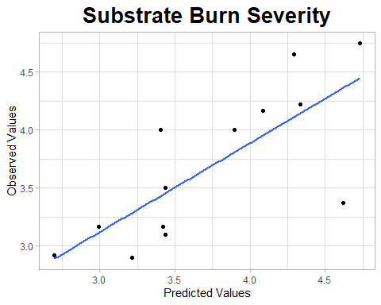
# use the model to predict test data
test_out<- predict.lm(lm1,test_vars)
errors<- test_out - test_pred$SubSev
mae <- mean(abs(errors))
mse <- mean(errors^2)
rmse <- sqrt(mse)
rmse
## [1] 0.7615366
# Plot test observed values vs. test predicted
data2<- data.frame(x=test_out, y=test_pred$SubSev)
ggplot(data2,aes(x,y)) +
geom_point() +
geom_smooth(method='lm', se=FALSE,) +
theme_light() +
labs(x='Predicted Values', y='Observed Values', title='test') +
theme(plot.title = element_text(hjust=0.5, size=20, face='bold')
)
## `geom_smooth()` using formula = 'y ~ x'
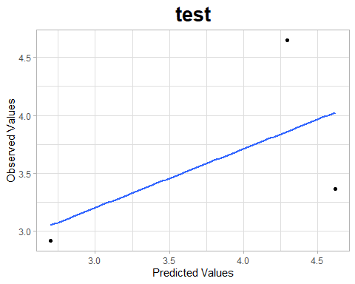

b. ROMO_East_RX_MeanScPct
model formula: lm1 <- lm(formula = train_pred$MeanScPct ~ h_l3_tgi +s_lng_zero_per + LF_SLPD )
library(tidyverse)
library(leaps)
library(performance)
library(ggplot2)
# Load pred / vars data
pred <- read.csv("TLS/intelimon models/RMNP Intelimon Update/3. ROMO_East_RX/b. ROMO_East_RX_MeanScPct/ROMO_East_RX_MeanScPct_pred.csv")
vars <- read.csv("TLS/intelimon models/RMNP Intelimon Update/3. ROMO_East_RX/b. ROMO_East_RX_MeanScPct/ROMO_East_RX_MeanScPct_vars.csv")
# Create training/test data
set.seed(123)
sample_size <- floor(0.2* nrow(vars))
test_indices <- sample(seq_len(nrow(vars)), size = sample_size)
train_vars <- vars[-test_indices, ]
test_vars <- vars[test_indices, ]
train_pred <- pred[-test_indices, ]
test_pred <- pred[test_indices, ]
# Load Model
lm1 <- readRDS("TLS/intelimon models/RMNP Intelimon Update/3. ROMO_East_RX/b. ROMO_East_RX_MeanScPct/ROMO_East_RX_MeanScPct.rda")
#look at the summary r2 values and RMSE & check model for colinearity
summary(lm1)
##
## Call:
## lm(formula = train_pred$MeanScPct ~ h_l3_tgi + s_lng_zero_per +
## LF_SLPD)
##
## Residuals:
## Min 1Q Median 3Q Max
## -5.8083 -2.4484 -1.5544 0.2044 13.1832
##
## Coefficients:
## Estimate Std. Error t value Pr(>|t|)
## (Intercept) 1184.0550 190.9430 6.201 0.000101 ***
## h_l3_tgi -1.5767 0.2430 -6.488 7e-05 ***
## s_lng_zero_per -12.0473 1.9661 -6.128 0.000112 ***
## LF_SLPD 3.0982 0.5696 5.439 0.000285 ***
## ---
## Signif. codes: 0 '***' 0.001 '**' 0.01 '*' 0.05 '.' 0.1 ' ' 1
##
## Residual standard error: 5.571 on 10 degrees of freedom
## Multiple R-squared: 0.8608, Adjusted R-squared: 0.8191
## F-statistic: 20.62 on 3 and 10 DF, p-value: 0.0001329
r2(lm1)
## # R2 for Linear Regression
## R2: 0.861
## adj. R2: 0.819
rmse(lm1)
## [1] 4.708101
check_model(lm1)
# Plot observed values vs. predicted
lm_out <- predict.lm(lm1, vars)
data<-data.frame(x=lm_out, y=pred$MeanScPct)
ggplot(data,aes(x,y)) +
geom_point() +
geom_smooth(method='lm', se=FALSE,) +
theme_light() +
labs(x='Predicted Values', y='Observed Values', title='mean Scorch Percent') +
theme(plot.title = element_text(hjust=0.5, size=20, face='bold')
)
## `geom_smooth()` using formula = 'y ~ x'
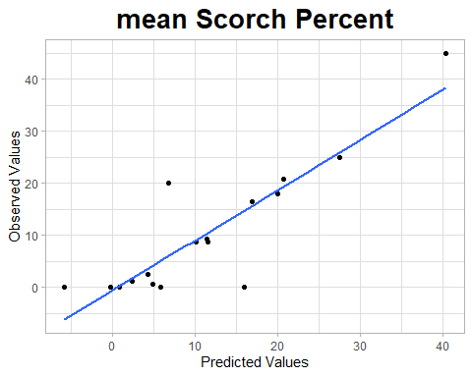
# use the model to predict test data
test_out<- predict.lm(lm1,test_vars)
errors<- test_out - test_pred$MeanScPct
mae <- mean(abs(errors))
mse <- mean(errors^2)
rmse <- sqrt(mse)
rmse
## [1] 9.248774
# Plot test observed values vs. test predicted
data2<- data.frame(x=test_out, y=test_pred$MeanScPct)
ggplot(data2,aes(x,y)) +
geom_point() +
geom_smooth(method='lm', se=FALSE,) +
theme_light() +
labs(x='Predicted Values', y='Observed Values', title='test') +
theme(plot.title = element_text(hjust=0.5, size=20, face='bold')
)
## `geom_smooth()` using formula = 'y ~ x'
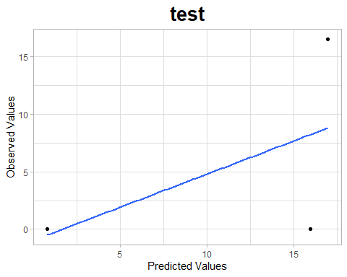

c. ROMO_East_RX_MeanScHt
model formula: lm1 <- lm(formula = train_pred$MeanScHt ~ h_l1_tgi + h_GC_median +fuel0_3l1_median )
library(tidyverse)
library(leaps)
library(performance)
library(ggplot2)
# Load pred / vars data
pred <- read.csv("TLS/intelimon models/RMNP Intelimon Update/3. ROMO_East_RX/c. ROMO_East_RX_MeanScHt/ROMO_East_RX_MeanScHt_pred.csv")
vars <- read.csv("TLS/intelimon models/RMNP Intelimon Update/3. ROMO_East_RX/c. ROMO_East_RX_MeanScHt/ROMO_East_RX_MeanScHt_vars.csv")
# Create training/test data
set.seed(123)
sample_size <- floor(0.2* nrow(vars))
test_indices <- sample(seq_len(nrow(vars)), size = sample_size)
train_vars <- vars[-test_indices, ]
test_vars <- vars[test_indices, ]
train_pred <- pred[-test_indices, ]
test_pred <- pred[test_indices, ]
# Load Model
lm1 <- readRDS("TLS/intelimon models/RMNP Intelimon Update/3. ROMO_East_RX/c. ROMO_East_RX_MeanScHt/ROMO_East_RX_MeanScHt.rda")
#look at the summary r2 values and RMSE & check model for colinearity
summary(lm1)
##
## Call:
## lm(formula = train_pred$MeanScHt ~ h_l1_tgi + h_GC_median + fuel0_3l1_median)
##
## Residuals:
## Min 1Q Median 3Q Max
## -1.8722 -1.3986 -0.8591 1.5195 4.0253
##
## Coefficients:
## Estimate Std. Error t value Pr(>|t|)
## (Intercept) -20.48003 6.99914 -2.926 0.015142 *
## h_l1_tgi -0.30471 0.09953 -3.062 0.012014 *
## h_GC_median 30.90159 9.52341 3.245 0.008798 **
## fuel0_3l1_median 826.61918 176.60213 4.681 0.000867 ***
## ---
## Signif. codes: 0 '***' 0.001 '**' 0.01 '*' 0.05 '.' 0.1 ' ' 1
##
## Residual standard error: 2.106 on 10 degrees of freedom
## Multiple R-squared: 0.7997, Adjusted R-squared: 0.7396
## F-statistic: 13.31 on 3 and 10 DF, p-value: 0.0007961
r2(lm1)
## # R2 for Linear Regression
## R2: 0.800
## adj. R2: 0.740
rmse(lm1)
## [1] 1.780242
check_model(lm1)
# Plot observed values vs. predicted
lm_out <- predict.lm(lm1, vars)
data<-data.frame(x=lm_out, y=pred$MeanScHt)
ggplot(data,aes(x,y)) +
geom_point() +
geom_smooth(method='lm', se=FALSE,) +
theme_light() +
labs(x='Predicted Values', y='Observed Values', title='mean Scorch Height') +
theme(plot.title = element_text(hjust=0.5, size=20, face='bold')
)
## `geom_smooth()` using formula = 'y ~ x'
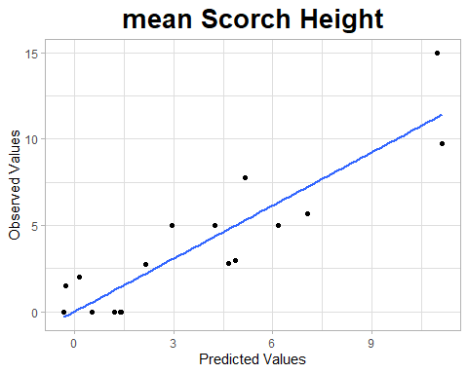
# use the model to predict test data
test_out<- predict.lm(lm1,test_vars)
errors<- test_out - test_pred$MeanScHt
mae <- mean(abs(errors))
mse <- mean(errors^2)
rmse <- sqrt(mse)
rmse
## [1] 1.663678
# Plot test observed values vs. test predicted
data2<- data.frame(x=test_out, y=test_pred$MeanScHt)
ggplot(data2,aes(x,y)) +
geom_point() +
geom_smooth(method='lm', se=FALSE,) +
theme_light() +
labs(x='Predicted Values', y='Observed Values', title='test') +
theme(plot.title = element_text(hjust=0.5, size=20, face='bold')
)
## `geom_smooth()` using formula = 'y ~ x'
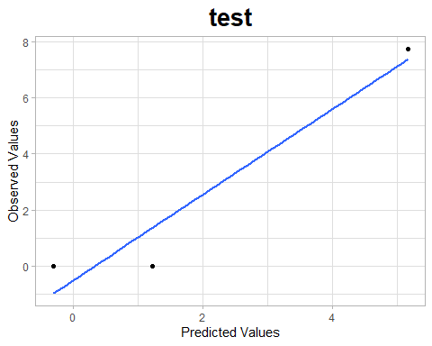

4. ROMO_West_Fuels

a. ROMO_West_Fuels_TotalAll
model formula: lm1 <- lm(formula = train_pred$TotalAll ~ h_MS_tgi + h_OS_per + LF_FDist)
library(tidyverse)
library(leaps)
library(performance)
library(ggplot2)
# Load pred / vars data
pred <- read.csv("TLS/intelimon models/RMNP Intelimon Update/4. ROMO_West_Fuels/a. ROMO_West_Fuels_TotalAll/ROMO_West_Fuels_TotalAll_pred.csv")
vars <- read.csv("TLS/intelimon models/RMNP Intelimon Update/4. ROMO_West_Fuels/a. ROMO_West_Fuels_TotalAll/ROMO_West_Fuels_TotalAll_vars.csv")
# Create training/test data
set.seed(123)
sample_size <- floor(0.2* nrow(vars))
test_indices <- sample(seq_len(nrow(vars)), size = sample_size)
train_vars <- vars[-test_indices, ]
test_vars <- vars[test_indices, ]
train_pred <- pred[-test_indices, ]
test_pred <- pred[test_indices, ]
# Load Model
lm1 <- readRDS("TLS/intelimon models/RMNP Intelimon Update/4. ROMO_West_Fuels/a. ROMO_West_Fuels_TotalAll/ROMO_West_Fuels_TotalAll.rda")
#look at the summary r2 values and RMSE & check model for colinearity
summary(lm1)
##
## Call:
## lm(formula = train_pred$TotalAll ~ h_MS_tgi + h_OS_per + LF_FDist)
##
## Residuals:
## Min 1Q Median 3Q Max
## -10.2785 -2.8486 0.3334 4.2040 11.4101
##
## Coefficients:
## Estimate Std. Error t value Pr(>|t|)
## (Intercept) 28.14568 4.35616 6.461 3.11e-05 ***
## h_MS_tgi -0.87641 0.23893 -3.668 0.00322 **
## h_OS_per 1.18745 0.19711 6.024 5.99e-05 ***
## LF_FDist -0.19854 0.03243 -6.123 5.15e-05 ***
## ---
## Signif. codes: 0 '***' 0.001 '**' 0.01 '*' 0.05 '.' 0.1 ' ' 1
##
## Residual standard error: 6.911 on 12 degrees of freedom
## Multiple R-squared: 0.8636, Adjusted R-squared: 0.8295
## F-statistic: 25.32 on 3 and 12 DF, p-value: 1.776e-05
r2(lm1)
## # R2 for Linear Regression
## R2: 0.864
## adj. R2: 0.829
rmse(lm1)
## [1] 5.985432
check_model(lm1)
# Plot observed values vs. predicted
lm_out <- predict.lm(lm1, vars)
data<-data.frame(x=lm_out, y=pred$TotalAll)
ggplot(data,aes(x,y)) +
geom_point() +
geom_smooth(method='lm', se=FALSE,) +
theme_light() +
labs(x='Predicted Values', y='Observed Values', title='Total Fuel Load') +
theme(plot.title = element_text(hjust=0.5, size=20, face='bold')
)
## `geom_smooth()` using formula = 'y ~ x'
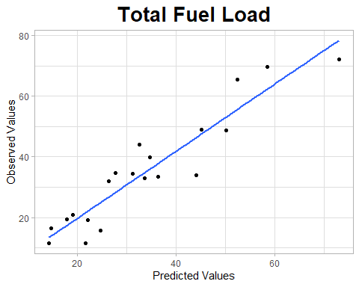
# use the model to predict test data
test_out<- predict.lm(lm1,test_vars)
errors<- test_out - test_pred$TotalAll
mae <- mean(abs(errors))
mse <- mean(errors^2)
rmse <- sqrt(mse)
rmse
## [1] 8.835522
# Plot test observed values vs. test predicted
data2<- data.frame(x=test_out, y=test_pred$TotalAll)
ggplot(data2,aes(x,y)) +
geom_point() +
geom_smooth(method='lm', se=FALSE,) +
theme_light() +
labs(x='Predicted Values', y='Observed Values', title='test') +
theme(plot.title = element_text(hjust=0.5, size=20, face='bold')
)
## `geom_smooth()` using formula = 'y ~ x'
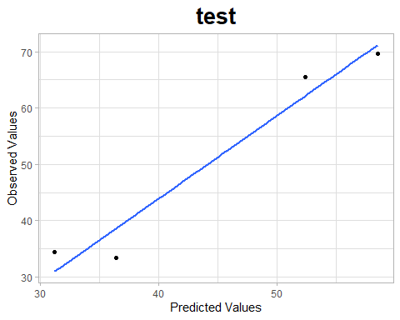

b. ROMO_West_Fuels_TotalWood
model formula: lm1 <- lm(formula = train_pred$TotalWood ~ h_l1_vari + hr100_1000_l1_std + LF_FDist)
library(tidyverse)
library(leaps)
library(performance)
library(ggplot2)
# Load pred / vars data
pred <- read.csv("TLS/intelimon models/RMNP Intelimon Update/4. ROMO_West_Fuels/b. ROMO_West_Fuels_TotalWood/ROMO_West_Fuels_TotalWood_pred.csv")
vars <- read.csv("TLS/intelimon models/RMNP Intelimon Update/4. ROMO_West_Fuels/b. ROMO_West_Fuels_TotalWood/ROMO_West_Fuels_TotalWood_vars.csv")
# Create training/test data
set.seed(123)
sample_size <- floor(0.2* nrow(vars))
test_indices <- sample(seq_len(nrow(vars)), size = sample_size)
train_vars <- vars[-test_indices, ]
test_vars <- vars[test_indices, ]
train_pred <- pred[-test_indices, ]
test_pred <- pred[test_indices, ]
# Load Model
lm1 <- readRDS("TLS/intelimon models/RMNP Intelimon Update/4. ROMO_West_Fuels/b. ROMO_West_Fuels_TotalWood/ROMO_West_Fuels_TotalWood.rda")
#look at the summary r2 values and RMSE & check model for colinearity
summary(lm1)
##
## Call:
## lm(formula = train_pred$TotalWood ~ h_l1_vari + hr100_1000_l1_std +
## LF_FDist)
##
## Residuals:
## Min 1Q Median 3Q Max
## -8.0774 -3.0016 0.3867 2.5792 10.4756
##
## Coefficients:
## Estimate Std. Error t value Pr(>|t|)
## (Intercept) 31.64873 5.60114 5.650 0.000107 ***
## h_l1_vari 0.24251 0.04021 6.031 5.93e-05 ***
## hr100_1000_l1_std -17.61699 6.18571 -2.848 0.014677 *
## LF_FDist -0.09975 0.03926 -2.541 0.025906 *
## ---
## Signif. codes: 0 '***' 0.001 '**' 0.01 '*' 0.05 '.' 0.1 ' ' 1
##
## Residual standard error: 5.806 on 12 degrees of freedom
## Multiple R-squared: 0.8574, Adjusted R-squared: 0.8218
## F-statistic: 24.05 on 3 and 12 DF, p-value: 2.308e-05
r2(lm1)
## # R2 for Linear Regression
## R2: 0.857
## adj. R2: 0.822
rmse(lm1)
## [1] 5.028544
check_model(lm1)
# Plot observed values vs. predicted
lm_out <- predict.lm(lm1, vars)
data<-data.frame(x=lm_out, y=pred$TotalWood)
ggplot(data,aes(x,y)) +
geom_point() +
geom_smooth(method='lm', se=FALSE,) +
theme_light() +
labs(x='Predicted Values', y='Observed Values', title='Total Woody Fuels') +
theme(plot.title = element_text(hjust=0.5, size=20, face='bold')
)
## `geom_smooth()` using formula = 'y ~ x'
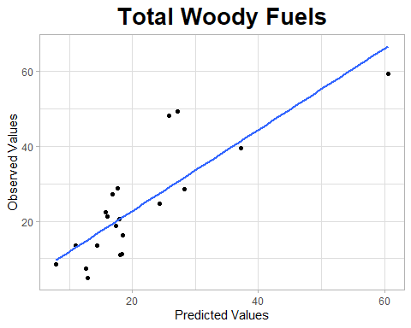
# use the model to predict test data
test_out<- predict.lm(lm1,test_vars)
errors<- test_out - test_pred$TotalWood
mae <- mean(abs(errors))
mse <- mean(errors^2)
rmse <- sqrt(mse)
rmse
## [1] 16.69486
# Plot test observed values vs. test predicted
data2<- data.frame(x=test_out, y=test_pred$TotalWood)
ggplot(data2,aes(x,y)) +
geom_point() +
geom_smooth(method='lm', se=FALSE,) +
theme_light() +
labs(x='Predicted Values', y='Observed Values', title='test') +
theme(plot.title = element_text(hjust=0.5, size=20, face='bold')
)
## `geom_smooth()` using formula = 'y ~ x'
